HW1:
求下列程式執行結果
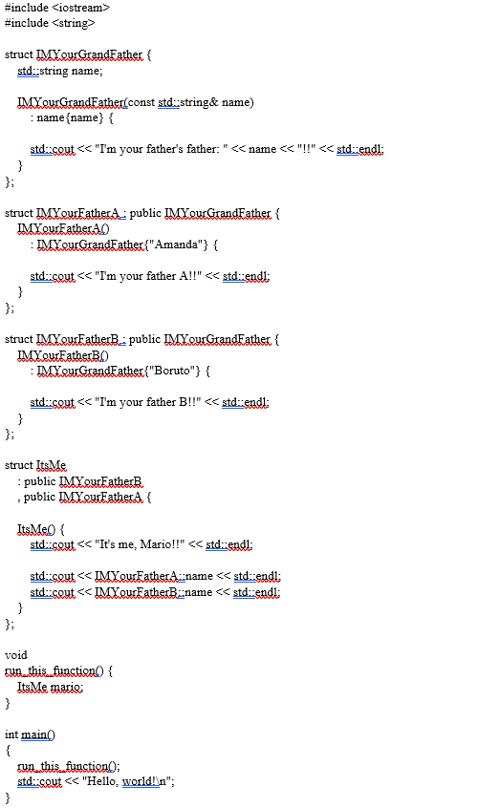
Ans:
I'm your father's father: Boruto!!
I'm your father B!!
I'm your father's father: Amanda!!
I'm your father A!!
It's me, Mario!!
Amanda
Boruto
Hello, world
HW2:
我如果想要進行鑽石型的繼承 (diamond-shaped inheritance) in C++
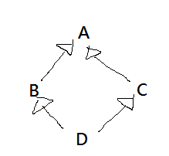
請寫下 C++ 的class A,B,C,D 的宣告，來達到這個繼承。
Ans:
class A {
};
class B : virtual public A {
};
class C : virtual public A {
};
class D : public B, public C {
};

